**EX.NO:4 DATE:4/9/2024**

**Reg.no:220701012**

**MINIMAX ALGORITHM**

• A simple example can be used to explain how the minimax algorithm works. We've included an example of a game-tree below, which represents a two-player game.

• There are two players in this scenario, one named Maximizer and the other named Minimizer.

• Maximizer will strive for the highest possible score, while Minimizer will strive for the lowest possible score.

• Because this algorithm uses DFS, we must go all the way through the leaves to reach the terminal nodes in this game-tree.

• The terminal values are given at the terminal node, so we'll compare them and retrace the tree till we reach the original state.  
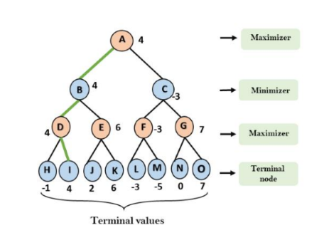

**CODE**:  
def minimax(depth, nodeIndex, isMaximizingPlayer, scores, targetDepth):

    if depth == targetDepth:

        return scores[nodeIndex]

    if isMaximizingPlayer:

        return max(minimax(depth + 1, nodeIndex * 2, False, scores, targetDepth),

                   minimax(depth + 1, nodeIndex * 2 + 1, False, scores, targetDepth))

    else:

        return min(minimax(depth + 1, nodeIndex * 2, True, scores, targetDepth),

                   minimax(depth + 1, nodeIndex * 2 + 1, True, scores, targetDepth))

if __name__ == "__main__":

    scores = [3, 5, 2, 9, 12, 5, 23, 23]

    targetDepth = 3

    optimalValue = minimax(0, 0, True, scores, targetDepth)

    print("The optimal value for the game is:", optimalValue)

OUTPUT:  
 